pipenv is a new way for us to combine package management with virtual environment and it’s also a highly recommended packaging tool from python.org

A lot of companies are switching over from pip to pipenv.

Basically, it’s combining the features of pip and virtual env

PIP is a package manager for Python packages, or modules if you like. Pip is a recursive acronym that can stand for either "Pip Installs Packages" or "Pip Installs Python". Alternatively, pip stands for "preferred installer program". Basically, pip is a way for us to install additional packages that allows us to add a ton of functionality that doesn’t exist in the Python Standard library. For example, if you want to do some image manipulation then python might not have the best tools available right out of the box, but you can use pip to install pillow library and we can use that library to work with images.

Virtual environment is a way for us to have a specific environment for each project or application that we’re building. So, for example you could have one application that runs with Python 2.7 and Django 1.5 and then another project that runs with Python 3.7 and Django 2.1, so each of those projects would have their own version of Python and their own packages which is usually how you want to do it.

Some people put off having virtual environments and just try to run every project using their global installation of Python and all the packages installed in one place but if you do it that way, then as soon as you update to the next version of Python or update your packages, then it could break some of your older applications that were running just fine. So, it’s best to split those up using virtual environments. So, before pipenv, we used pip to handle package management and used virtual env to handle virtual environments, but now with pipenv, these can all be handled by one tool that simplifies the process.

Let’s get started, so first we want to install pipenv and we can simply install pipenv by using pip

**pip install pipenv**

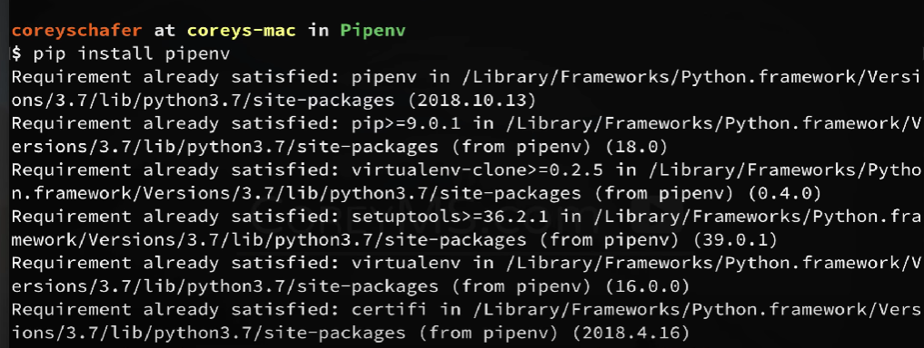

Now, we have installed pipenv

Now, let’s pretend that we’re starting a new project, so that we can see how we can install packages for that project and also create a virtual environment automatically.

At this point, if we are using the old method of installing packages for this project, then at this point, we would create a virtual environment using one of the older tools to do that and then we would need to manually activate that environment and then start installing the packages that we want to use in this project, but with pipenv this is all built-in together now. So, instead of creating a new virtual environment manually, we’re simply going to install the packages that we want with pipenv.

Let’s say that we want to use request package for this project,

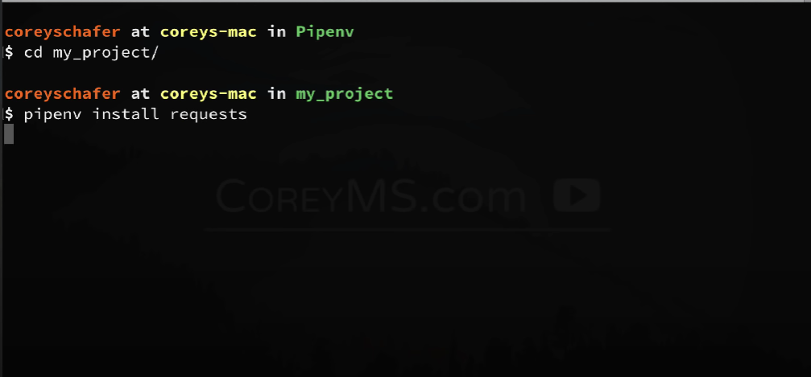

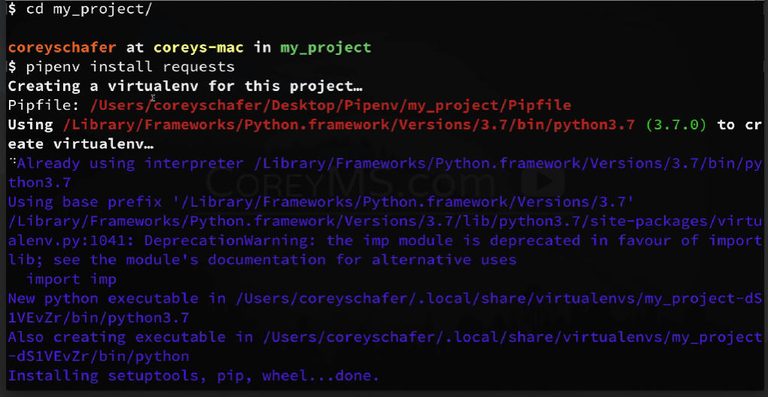

So, right after we installed the request using pipenv, it first notices that we don’t have a virtual environment for this project. So, it creates one for us (see the line **Creating a virtualenv for this project…**)**.** Then it gives us a location of a pipfile, and next line saying that it is using that version of python which is where my python 3.7 installed and then it goes through creating that environment for us.

And when you scroll down

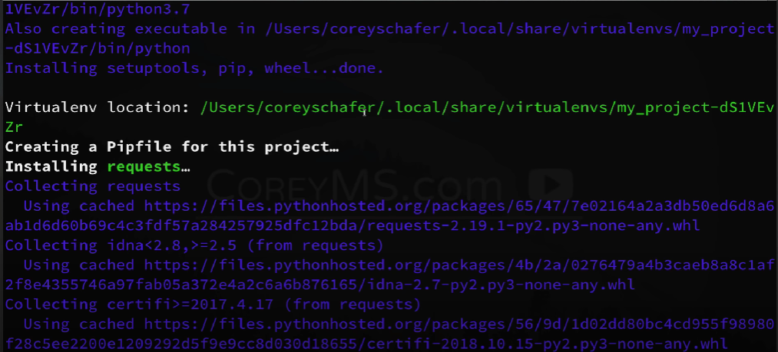

It tells us the location of our virtual environment and the virtual environment that it created is actually just a regular virtual environment like you had used in the past. So, you can navigate to that location and activate it manually if you would like. But pipenv gives us simpler commands to interact with that environment than to just do it manually

Next it says that it has created a pip file. The pip file is going to be a file that describes our environment and how we can build it back from the scratch. So, this is similar to the requirements.txt file that some of you may have used before with pip and it’s actually will be a replacement for the requirements.txt file within pipenv.

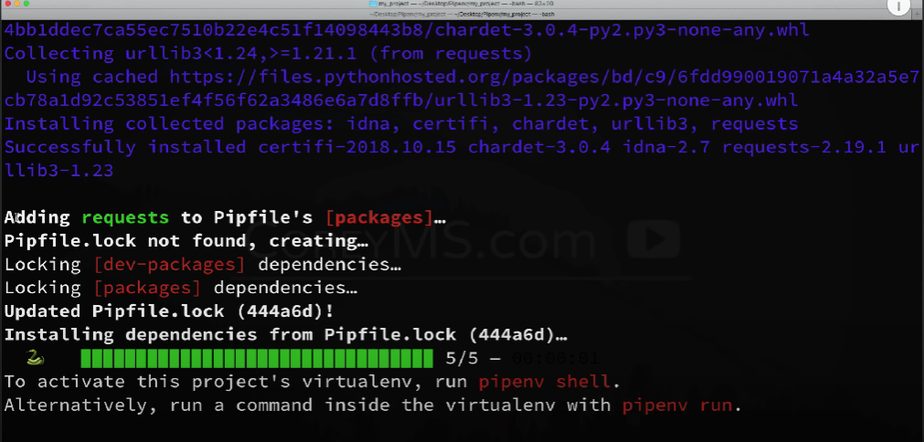

Now, it says that it added requests to our pip files packages, then it says this pipfile.lock not found and so, it’s creating it. So, pipfile.lock is another file that gets created and it’s similar to our pip file but with some key differences. And basically pipfile.lock is a file that we’re not supposed to touch. It’s just a file that gets generated and produces deterministic builds.

So, lastly, here at the bottom, we can see that it tells us that we can activate our new environment simply by saying **pipenv shell** and if we want to run the command inside that virtual environment then we can do **pipenv run.**

Let’s look at pip file and pipfile.lock

Pip file:

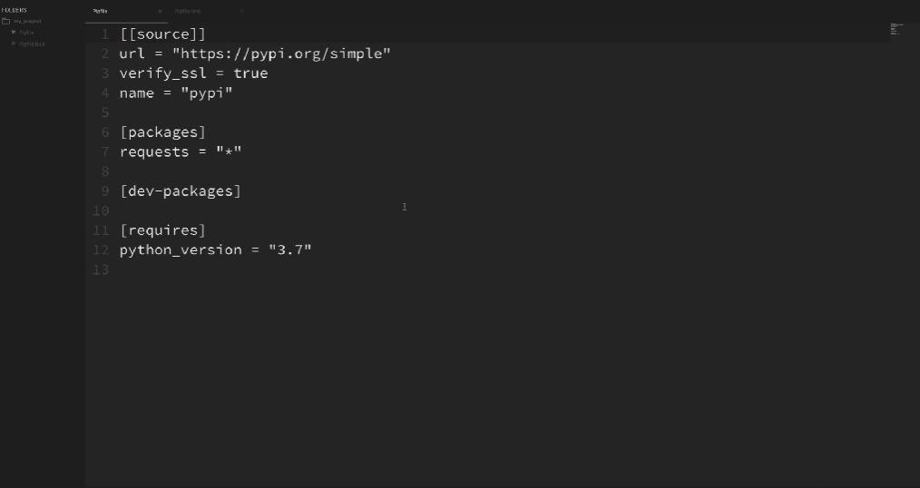

The format that pip file using is **toml** which is designed to be a minimal format that mostly contains keys and values within these sections. So, we have source sections here that shows where we’re downloading packages from and right here, it’s showing it’s downloading it from pypi.org and then we have packages section, we can see that currently it contains requests package and it says that and request = “*” which means that we didn’t specify a specific version when we installed requests package, if we had, then that would be, it would say, requests equal to that specific version. Now this is nice, right? because we’re not specifying an exact version, so any time we run pipenv install, it’ll go out and see if there are newer versions available for us and if there are, then it will update those versions automatically. So, this is something that we would have needed to do manually in the past with pip

Now, like we talked about before, like we updating packages like that can also be risky because we don’t want to take any chances of updates breaking our project. So, that’s where pipfile.lock is for.

Also, if we want to specify an exact version of the package here in the pip file, then we can do that too and it would just stay with that version even if a newer one is available

At the bottom, requires section, specifying which version of python that we’re using. So, I’m using Python 3.7, but we could change that if we like.

Remember: PIP file is a pretty simple file that just shows how we can create a new environment from scratch and this file is also meant to be editable. We could add packages in it and rerun the install command and it would install the packages that we added.

Pipfile.lock

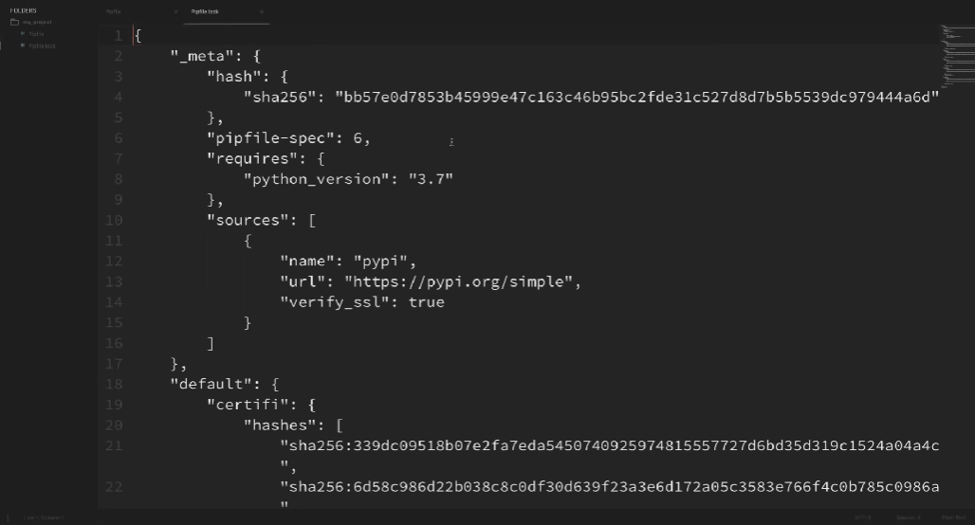

Note: This is a file that we’re not actually meant to change manually, this is a generated file that has more detailed information about our current environment. And this file even contains the dependencies that are installed when we installed the requests library, but not only that, it also has the exact version of each of these packages that were installed. So, this will give you a deterministic build and what I mean by that is, this lock file will absolutely give you the exact same environment every time and you only get a different build when you explicitly update the lock file and we’ll see how to do this

So, this gets us around the problem that we had before, where I said that updating packages can break your project. So, the pip file could see a new version of your package and update them accordingly and then once you’re sure that all of your code is still working in development after you’ve updated those packages then you can simply update your lock file which will give you the exact packages that are installed at that time that you know work well. And once you update that lock file then you can push that all to production

Now, we looked over the pip file and pipfile.lock and what the differences are there between those. Now, let’s actually activate our environment and go through some other commands to see how to do all of this

Let’s activate our environment,

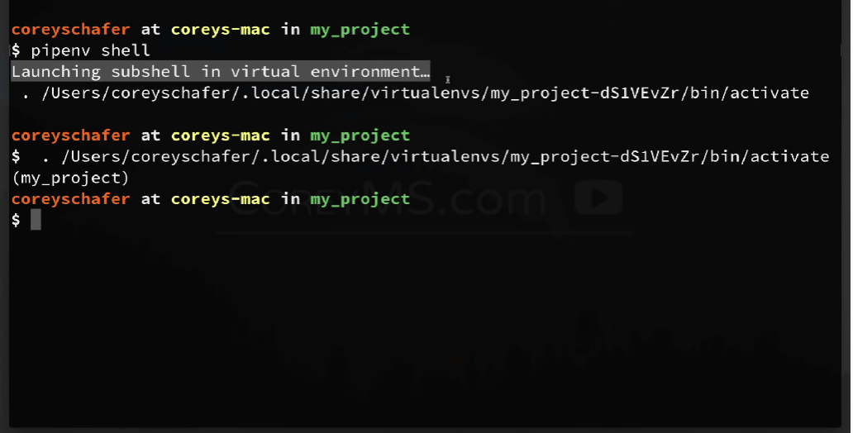

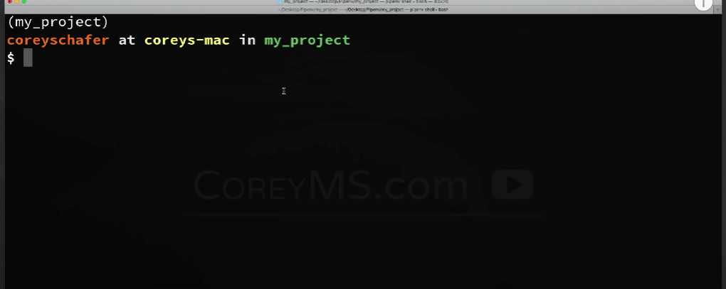

It also actually put us in environment where it will now be using a different Python interpreter and a different location for all of our packages.

Let’s check our current Python executable,

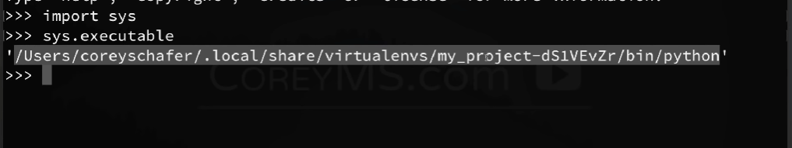

As you can see, the python that it is actually using is in this location here and that’s the virtual environment in that **virtualenvs** directory. So, that’s the good thing, which means whatever we install in this project will be separated from other projects on our machine

# Refer 🡪 How to Set the Path and Switch Between Different Versions/Executables

Now, let’s say that we want to deactivate the environment, we can do that by using **exit** command

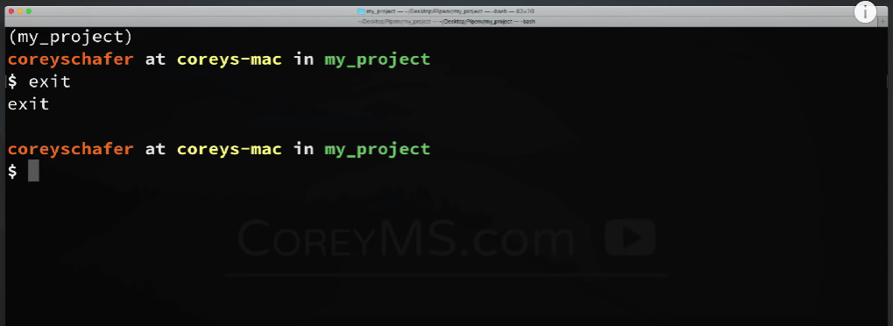

Now, there might be some confusion here that we used exit to deactivate the environment instead of using deactivate which we might have been used in older virtual environments. Thing is, if you use deactivate, then it could actually look like it does something but it won’t actually exit completely and that’s because pipenv actually launches a subshell to activate the environment and to exit that completely, we need to use the exit command. So, be sure you use exit command not the deactivate command.

The other interesting thing is, we can actually run commands in our environment without activating it, so we can do that with **pipenv run command.** Let’s say that I want to run python within our current environment. So, we could activate the environment like we just did with pipenv shell and then run python or we could just simply say **pipenv run python** and this will run that python command within that environment

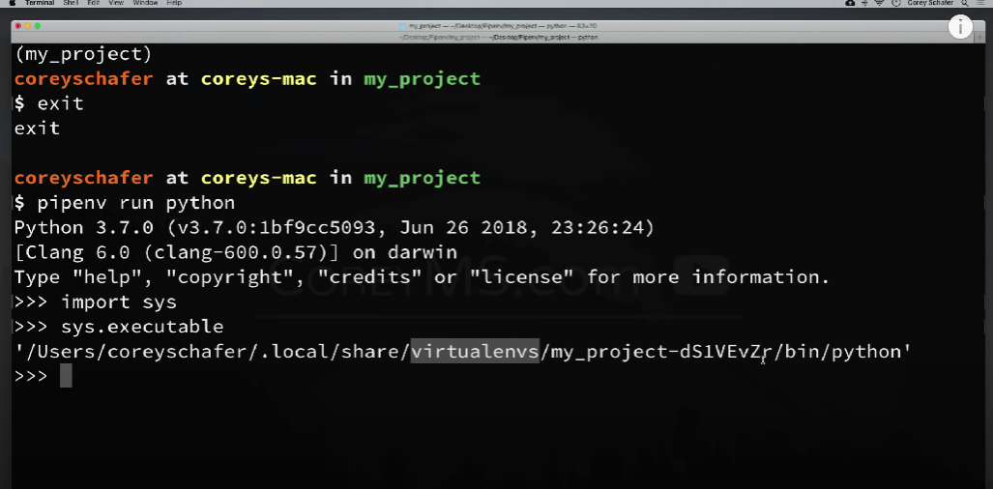

So, now let’s install more packages for this project. Now, we could do that one at a time using the install command that we saw before, but let’s see how to install several packages from an existing project. So, those of us who have used pip before, you’ve probably used requirement.txt file. So, if you start using pipenv, you can still use your requirements.txt file before you completely switch over to using pip files.

So, for example, I have a requirements.txt file that has all of the dependencies that I use in my Django course. So, let’s say that we wanted to install those here using that requirements.txt file. So, to do this, I can simply say **pipenv install -r requirements.txt**

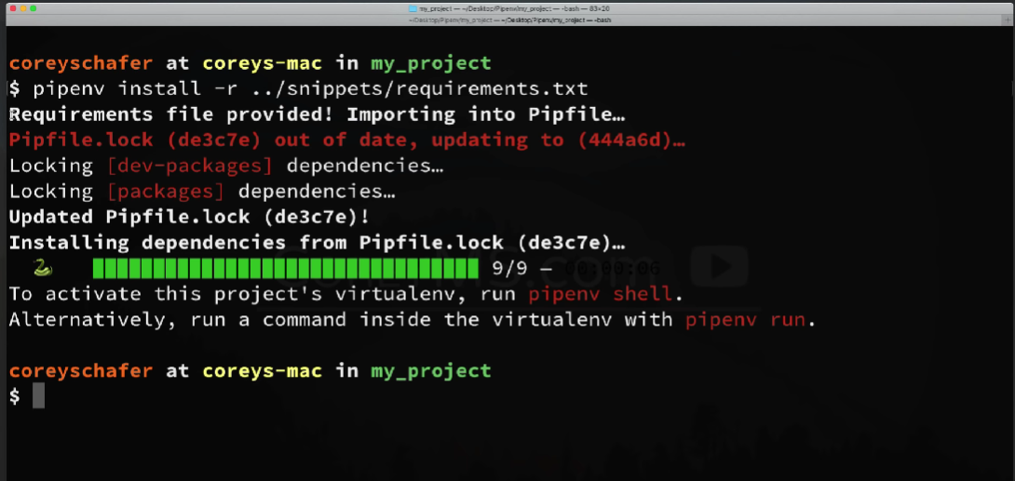

when you run this command, it says requirements file provided importing into pip file, it says it updated pipfile.lock, installed dependencies and it’s done.

Now, as soon as you open your pipfile

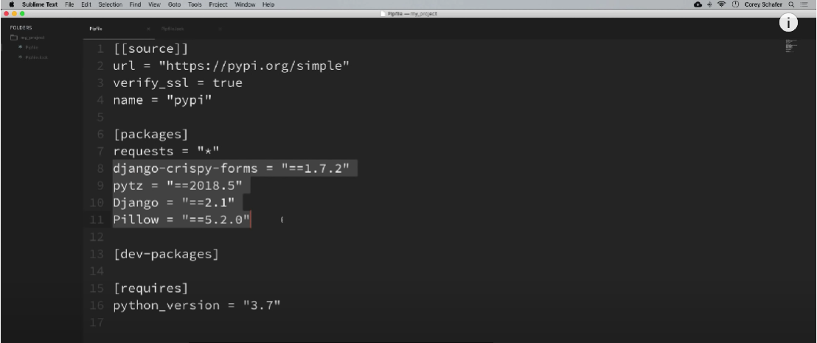

As you see your packages section, that these new packages were added to our pip file and those are the exact versions that were listed in my requirements.txt file.

Now, if you’re using pipenv but people on your team are still using pip, then you might need to create a requirements.txt file to send to them.

Note: The pip command to display the list of dependencies that you’d use in a requirements.txt file is **pip freeze**

Now, we can do that equivalent in pipenv by running **pipenv lock** command

Let’s see how it can be done,

**pipenv lock -r**

This displays the dependencies in a way that they would be added to the requirements.txt file

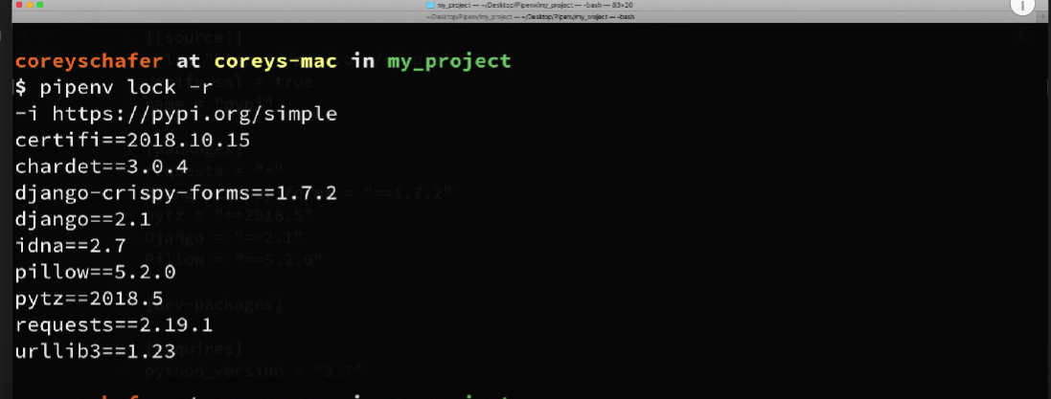

So, this is a good thing, creating a requirements.txt file in the pipenv also, because if your team is still using pip but you want to move on pipenv, then you don’t necessarily need everybody to switch over at the same time, you can start using it and features like this just make those easy to use together.

Let’s see some additional pipenv commands

Now, let’s how to install a package only in a dev environment. You can imagine that there are probably going to be some packages that you’ll need for the project in your dev environment, that you might not need in production, so for example, let’s say that we’re using pytest to test our code but we don’t actually want pytest included when we ship our code to production, so to do this, we can simply install a package normally but include the dev option in the end

**pipenv install pytest –dev**

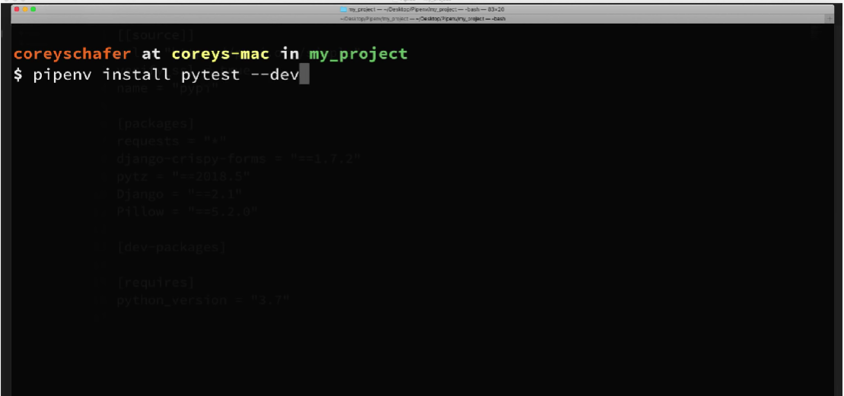

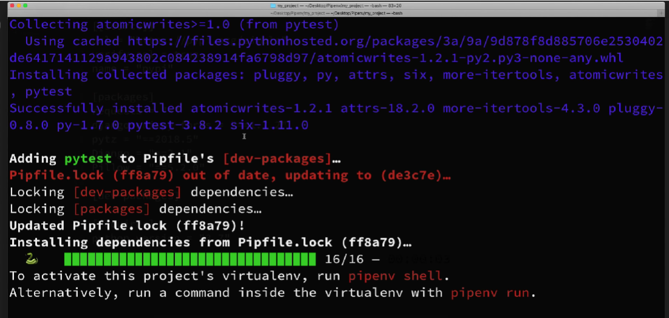

As you can see, Adding pytest to pipfile’s [dev-packages]. So, let’s go back to our pipfile and look

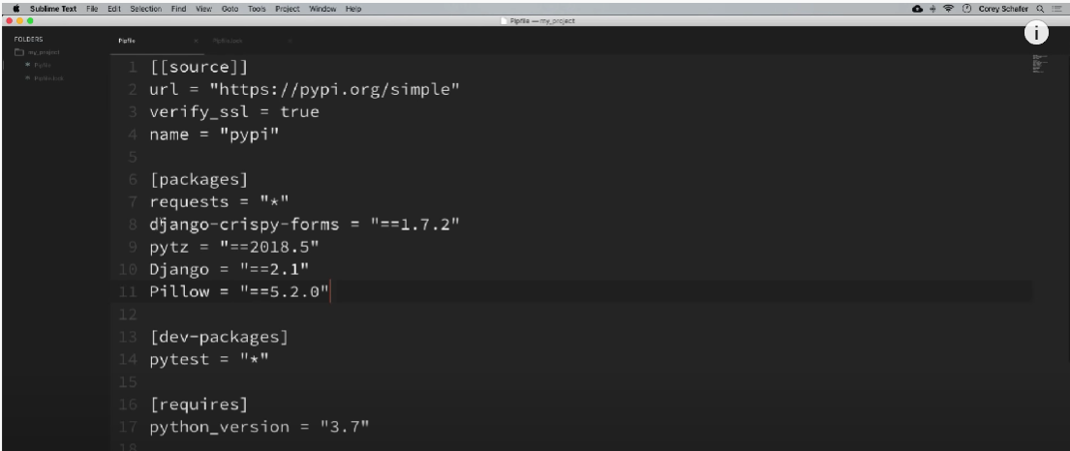

So, you can see, it didn’t add anything to our packages section and added pytest to dev-packages section.

Now if you ever want to remove any of these packages that we’ve installed, we can use **uninstall** command

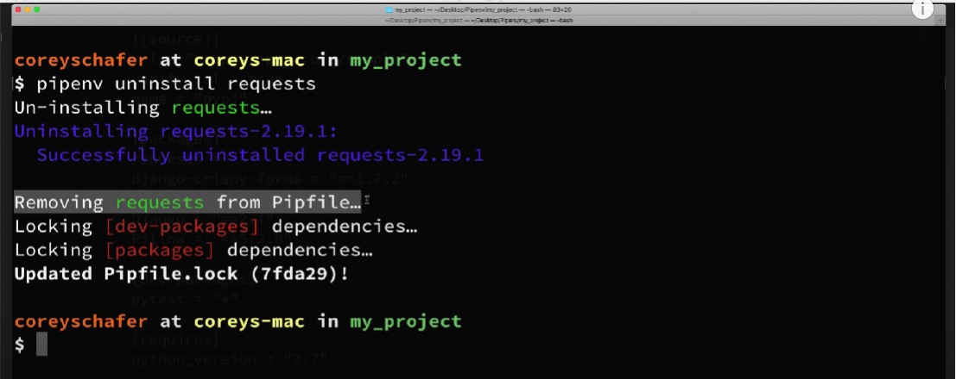

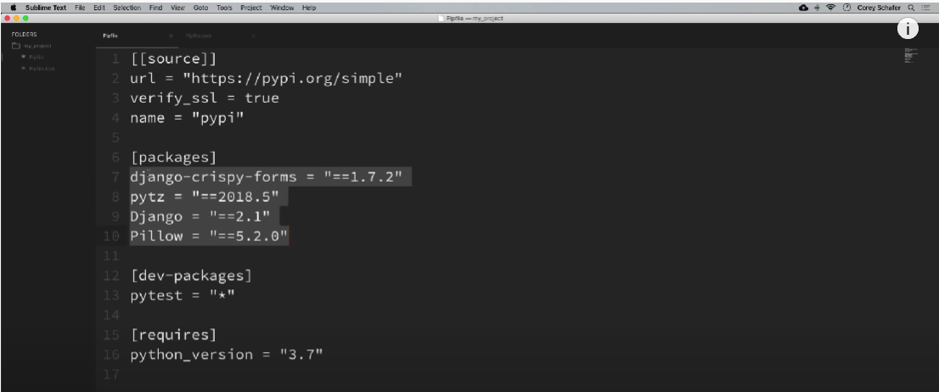

We can also do changes in pip file itself,

Let’s say that we want use a different version of python for this environment

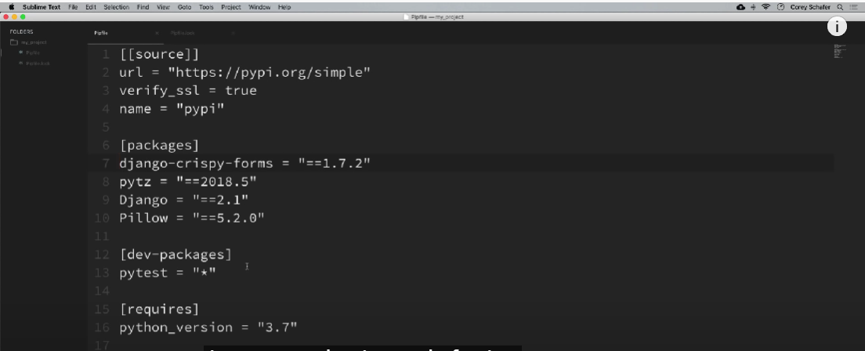

Let’s say that we actually need to Python version 3.6 instead of 3.7, Now say if we’re using the old way of using virtual environments then we might need to just export our requirements and then delete the environment and recreate it from scratch, but using pipenv is going to be lot easier, there are actually a couple of ways that we can do this, so the first way we could do this is that we can just come in here in the pipenv file and change the version of python. Once you changed it, you need to recreate you environment since the existing one is using Python 3.7

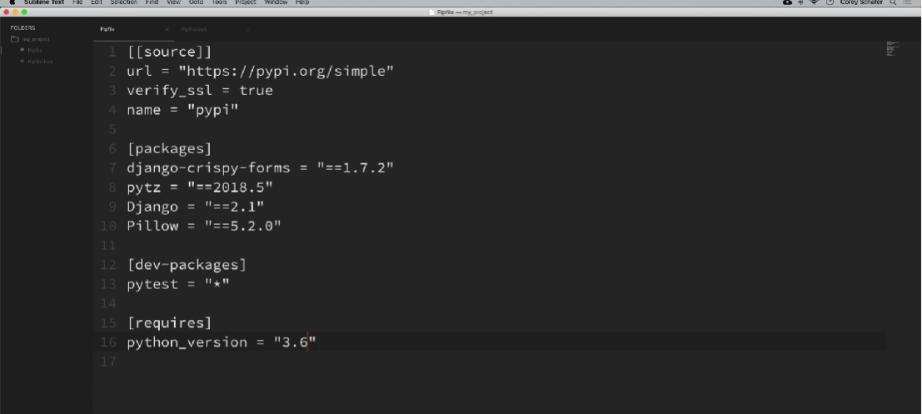

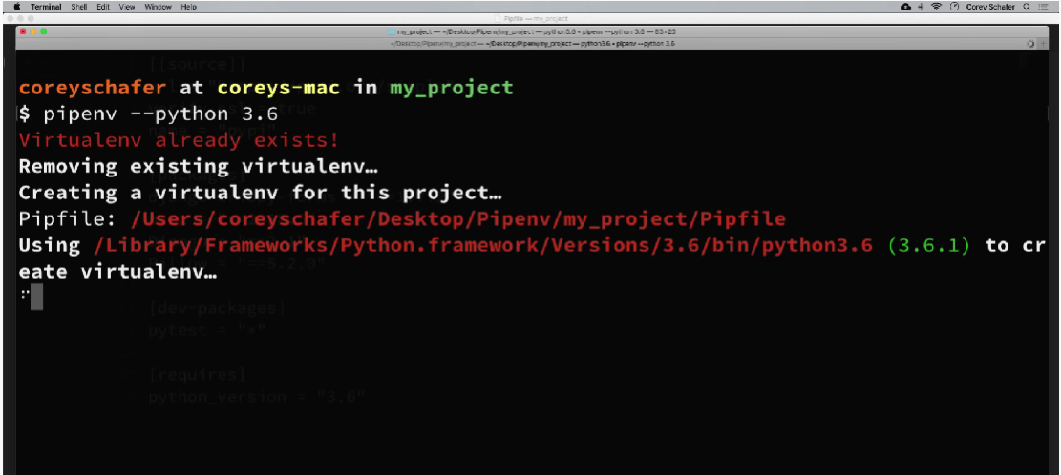

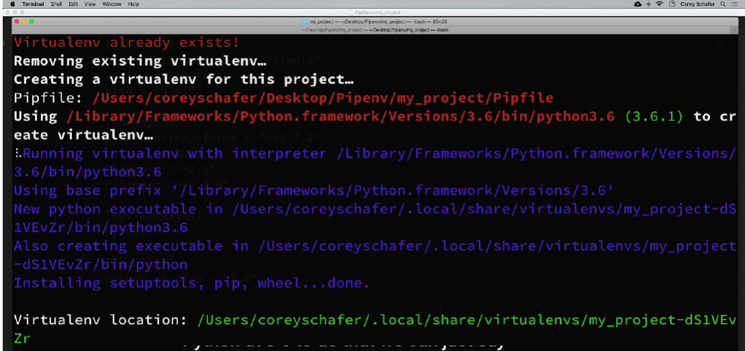

As you can see, the first line says, virtual env already exists, so we want to remove the existing virtual env and now it creates a virtualenv for this project and this time it’s using python 3.6

Let’s check it out,

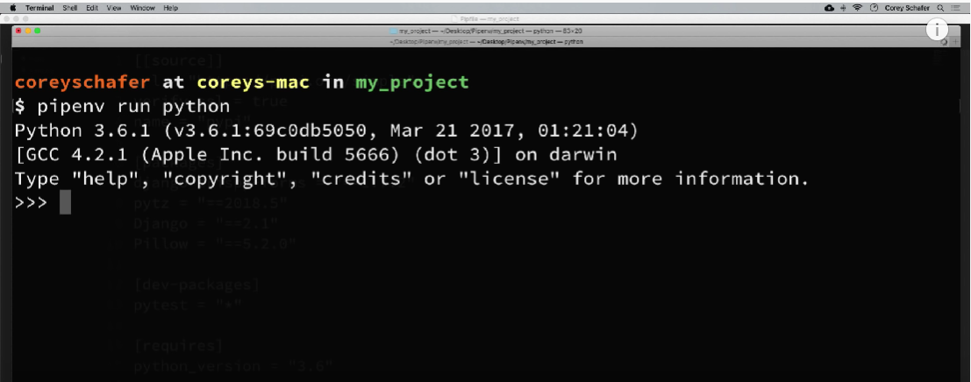

And the new environment that has been created will also be in the virtualenv directory

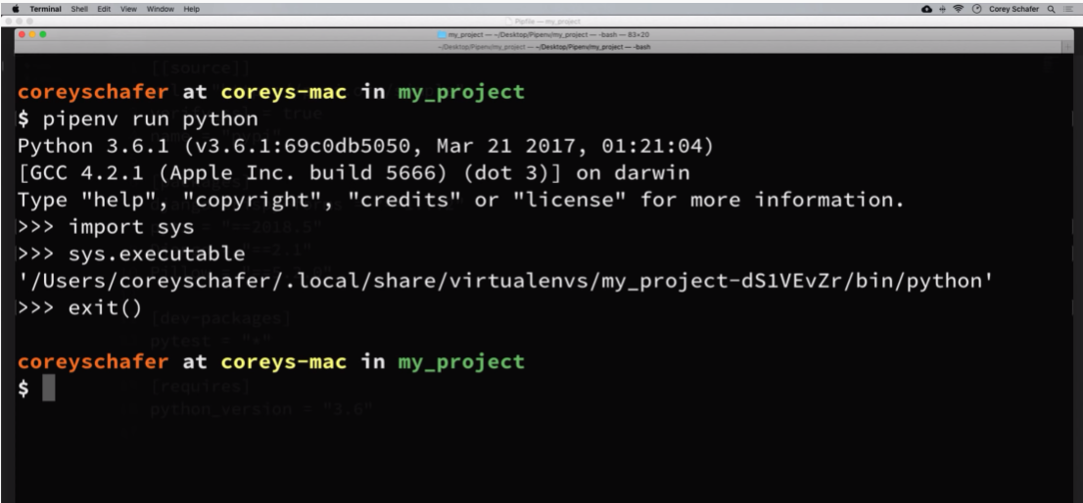

Now other way that we could have done that would have been to just remove the environment completely and then just recreate it from scratch using the pipfile and if your pip file environment ever gets too far out of sync, then it might be better just to delete the environment completely and then just recreate it from scratch. Let’s see how to do this,

Let’s say that we’re going change our project back to using Python 3.7

Go down to your pipfile and change the Python version to 3.7 and save it

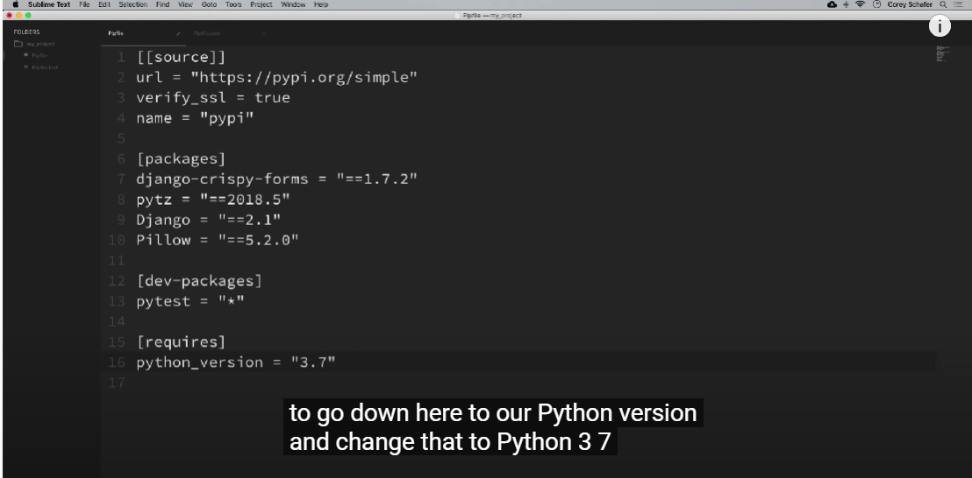

Open your terminal, let’s just throw this entire environment away and recreate from scratch using the pipfile

So, to remove the virtual environment completely, we can simply say **pipenv --rm**

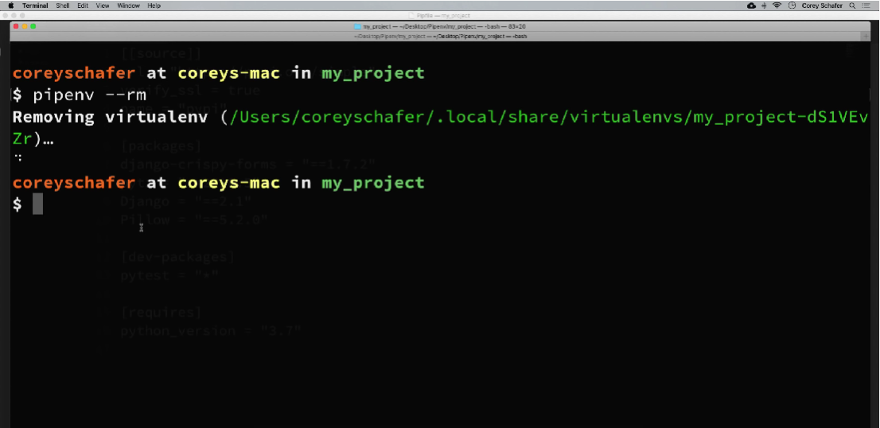

It saying that it’s removing virtual environment and gives the location to the virtual environment.

Now that it only removes the environment that we were using but everything that we need to recreate that environment is still within the pipfile. So, to create an environment that matches the one in our pipfile, we can just simply say **pipenv install**

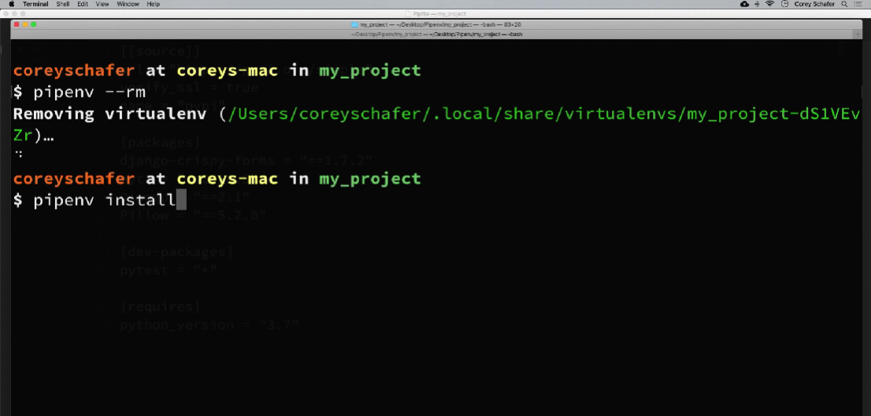

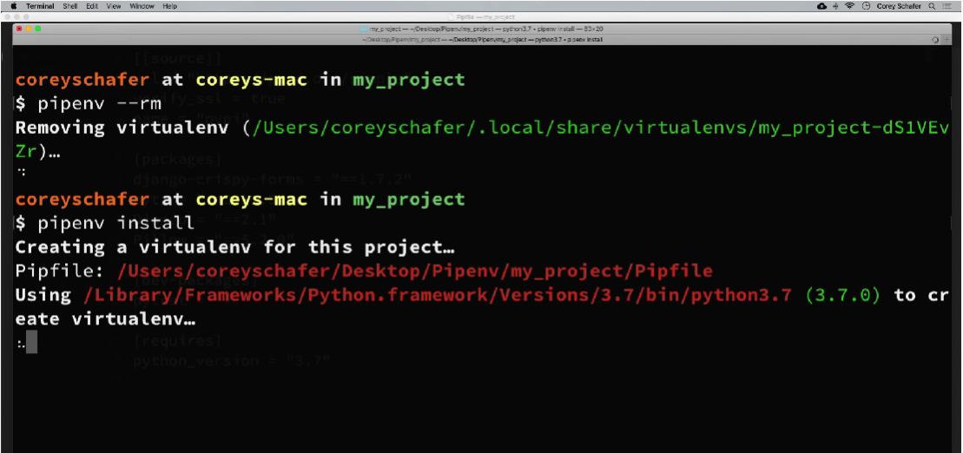

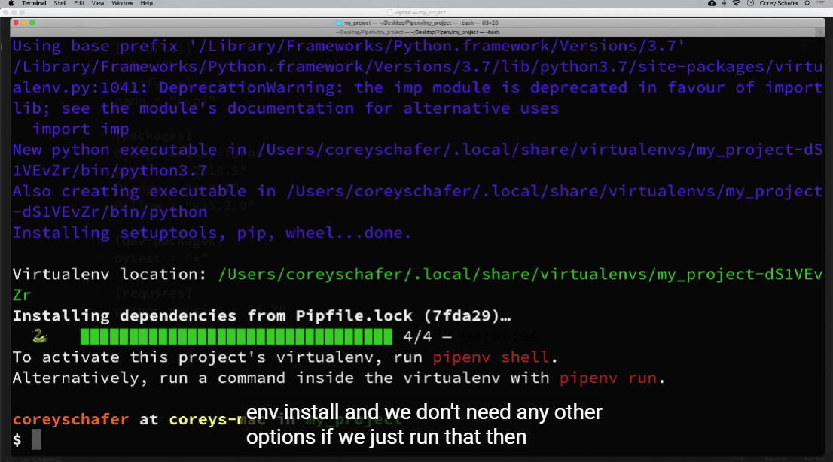

So, this will go through and create our environment from scratch using the Python version and packages from our pip file.

You can also check your path to your virtual environment, if you’re so curious

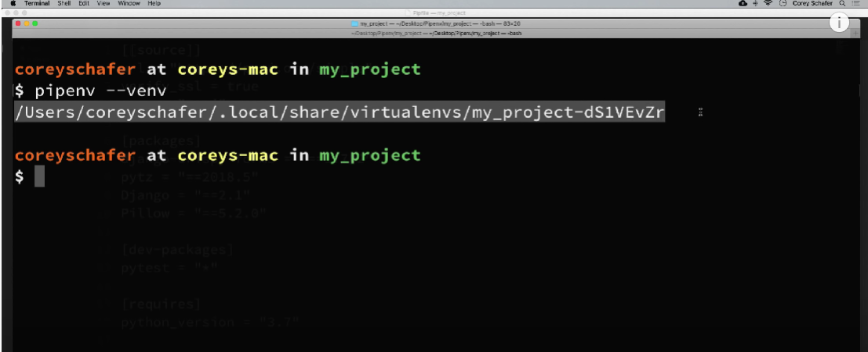

Another interesting feature with pipenv is that we can easily check for known security vulnerabilities for any of our installed packages, so to do that, you can say **pipenv check**

Let’s do that,

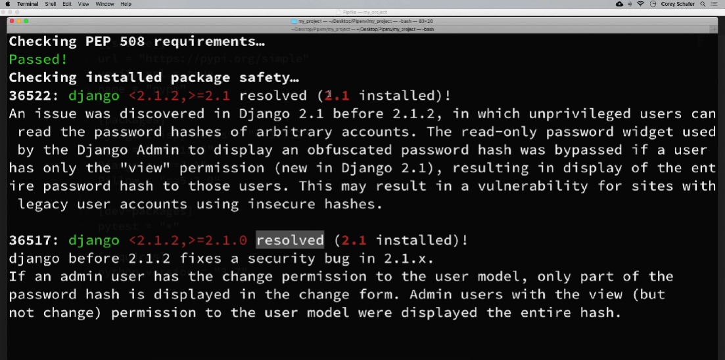

It’s saying that we have 2.1 installed but that we could’ve installed 2.1.2, so we can update that in our pipfile

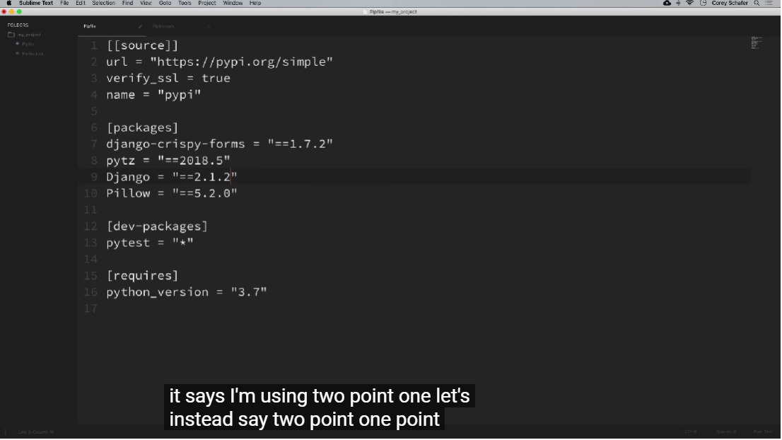

Once you changed and saved it, run the install command again, so that will those changes from our pip file

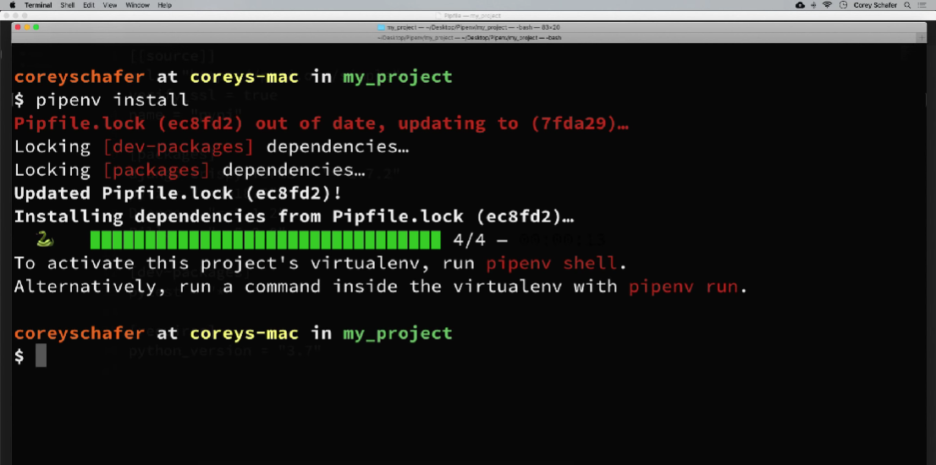

When we run pipcheck again,

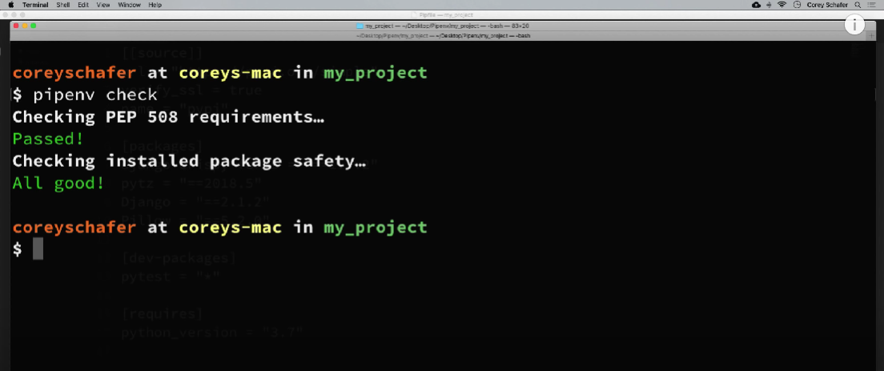

Let’s talk about the feature pipenv graph, that will display the dependency graph showing your packages and the dependencies for each of those

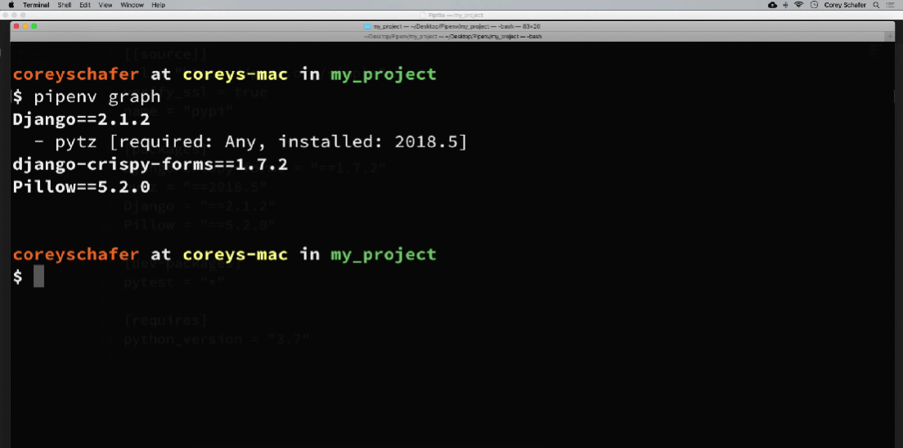

So, we can see here our packages and dependencies for those packages pytz is listed as dependency of Django, so, if you’re ever wondering why certain packages are installed or trying to debug, you know conflicting the dependencies then you can run pipenv graph to see a map of what depends on what.

Let me show you an example of what you do once you’re ready to push your code to production. So, currently our installs have been using the pipfile to create our environment but if you remember that I said that pipfile isn’t deterministic but the pipfile.lock is.

Pipfile.lock has the exact hashes and versions for specific packages that we’re currently using in our project but the pipfile might just tell us to grab the latest version of a package. Getting the latest version is fine in the development but when we push everything to production, we want to know that we’re pushing the exact versions of the packages that have already passed all of our testing. So, once you’ve tested all of your code and you know that you’re ready to push what you have done so far, then you can create or update pipfile.lock with the current dependencies by saying **pipenv lock**

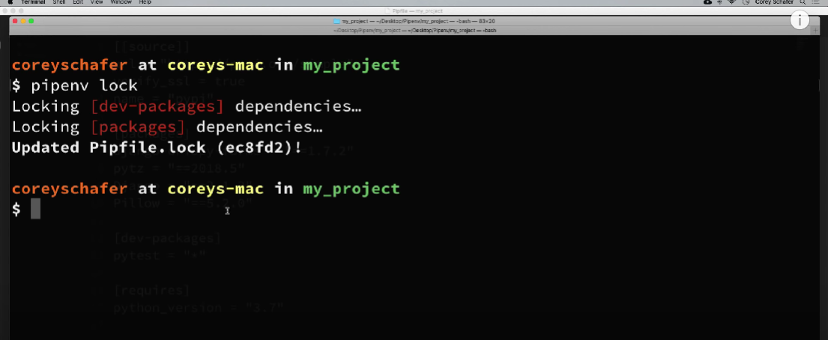

You can see that it has updated the pipfile.lock. So, once that’s done then you can take your pipfile.lock and move it to your production environment

And once you’re ready to install everything that’s in your pipfile.lock then you can simply run the command **pipenv install --ignore-pipfile**

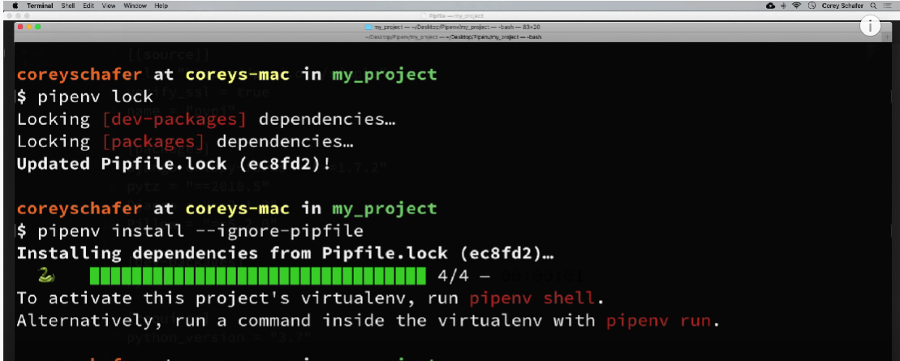

And this will create an environment using what is in the pipfile.lock and ignore the pipfile

Now let’s see how to set environment variables that are specific to the environment. Now this is something that some tools overlook but I think it’s extremely important, so for example if you’re working on multiple flask or Django projects and want to have environment variables for each project that contains the project secret key and database connection information and some other things like this, then it would be nice to have the virtual environment handle this without needing to do that manually

So, we can do this by using pipenv is to create .env file within your project directory and you can set that environment variable within that file or any or multiple of our environment variables within that file. So, let’s create this and see what this looks like

In your project directory, create a .env file and within this .env file, we can add our environment variables that we want to accessible in our environment

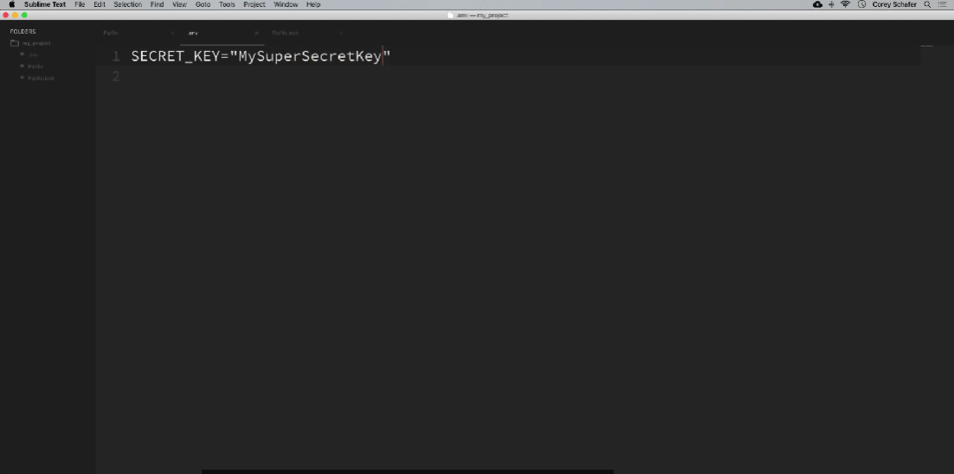

Let’s go back to the command line here and now let’s see if we can see that environment variable within our environment.

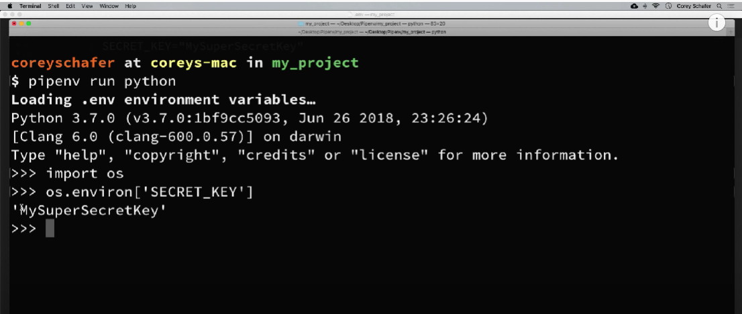

The usage of having environment variables is that you might have multiple projects that all have the same environment variable names, say for example, flask and Django projects are most likely all going to have secret keys and you don’t want to manage all of those manually, it’s better to just put them in a .env file specific to that project. Now another thing is that you do not want to commit those .env files to your repository. So, if you’re using git or something like that, then you’re most likely going to want to add that .env file to your git ignore file because you don’t want to commit it for other people to see, because it's going to could possibly have sensitive information like database connection, strings and passwords and other things like that.